Assignment 4
- Write an SQL query to display the names and salaries of employees whose salary is greater than the average salary in the company. Explain how the subquery works.
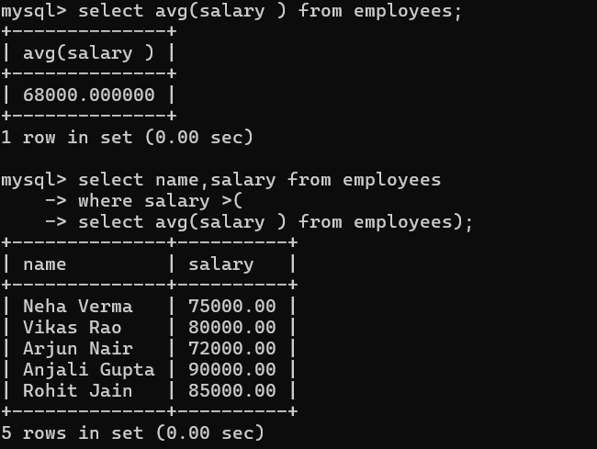
The subquery (select avg (salary) from employees) calculates the average salary of all employees. Then the outer query selects employees whose salary is greater than that average. The subquery runs first, returns a single value (average salary), and then the outer query compares each employee’s salary with that value.

- Write a query to retrieve the top 5 highest-paid employees from an employees table. Explain how sorting affects the output.

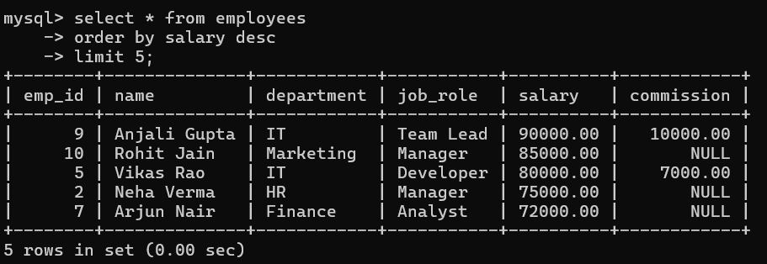

Order by salary desc sorts salaries from highest to lowest. Limit 5 selects only the top 5 records. Sorting determines which records appear first.

- Write a query to calculate:
• Total number of employees
• Average salary
• Minimum and maximum salary
Explain the difference between aggregate and scalar functions.
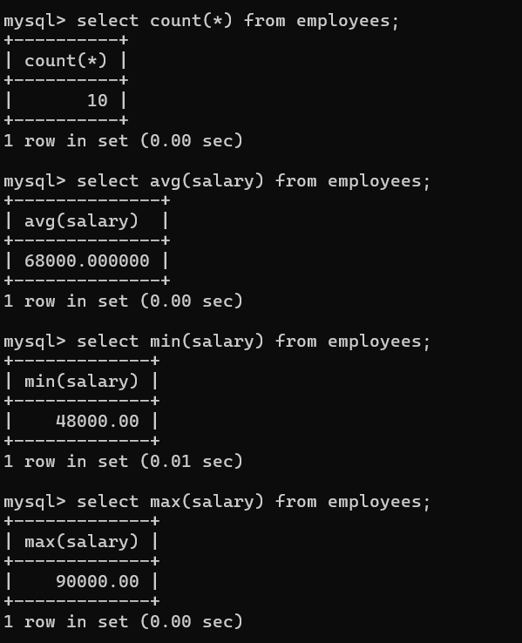
Difference Between Aggregate and Scalar Functions:
Aggregate Functions | Scalar Functions
Work on multiple rows | Work on single value
Return one result | Return one result per row
Example: COUNT(), AVG(), SUM() | Example: UPPER(), ROUND(), LENGTH()

- Given a sales table with columns (region, amount), write a query to find total sales per region. Filter only those regions where total sales exceed 50,000.

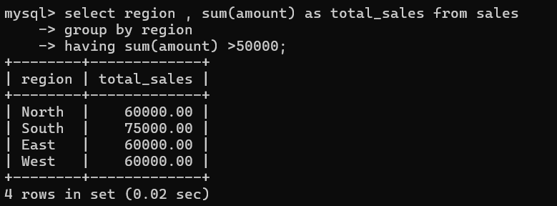

- Write a query to find the number of unique job roles in an employees table. Explain why DISTINCT is necessary here.
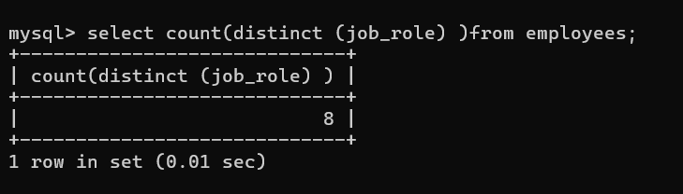
Without distinct, duplicate job roles would be counted multiple times. Distinct ensures each job role is counted only once.

6. Write a query to retrieve students who scored between 60 and 80 marks. Rewrite the same query using BETWEEN.
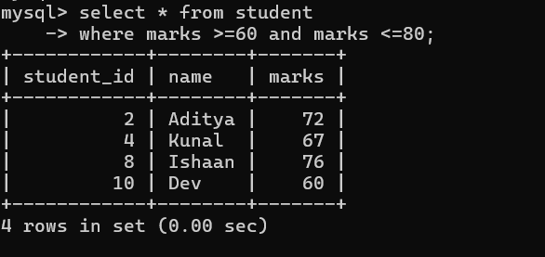

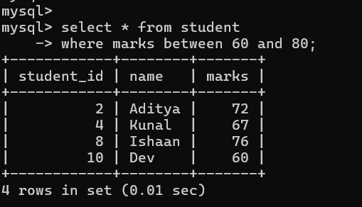

7. Write a query to display employees whose commission is NULL. Explain the correct way to check NULL values in SQL.

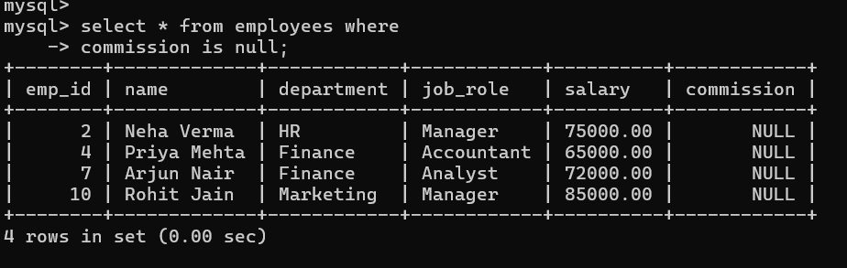

8. Write a query to increase the salary of employees in the “IT” department by 10%. Explain how arithmetic operations are handled in SQL.
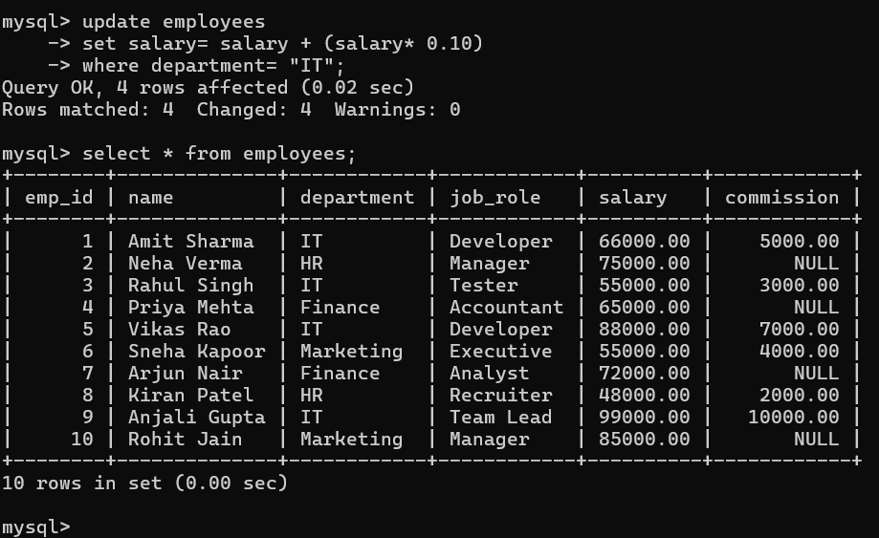

9. Write a query to delete records of students who scored less than 40 marks. What precaution should be taken before executing DELETE?
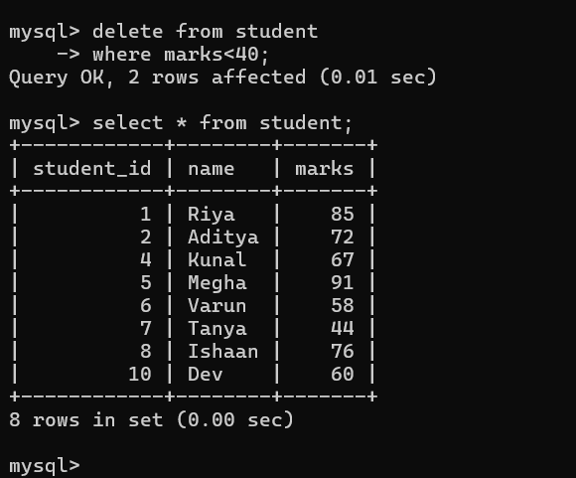
precaution should be taken before executing DELETE--
Always run a SELECT first to check affected rows.

10.Write a query to find employees who earn more than the average salary of their department (without using joins). Explain the logic of the subquery.

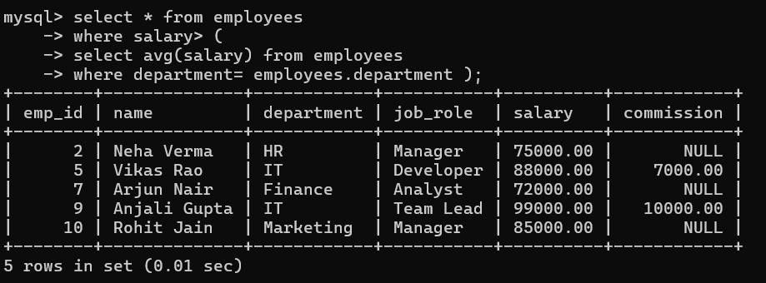

IN this subquery, for each employee, the subquery calculates the average salary of that employee’s department. Then it compares the employee’s salary with their department’s average. The subquery runs once for each row in the outer query.

